BGA Void Inspection Report
Quantitative & qualitative void analysis per IPC-A-610 / IPC-7095
Board / image | PCBA1_07.jpg
Report generated | 2026-07-09 19:57
Inspection tool | BGA X-ray Void Inspection Tool
Standards applied | IPC-A-610 / IPC-7095
BGA grid / balls analyzed | 256 expected pads, 256 analyzed
IPC VERDICT: ACCEPT WITH PROCESS INDICATORS
No IPC-A-610 defect. 2 ball(s) in the 10-25% process-indicator band (IPC-7095 process guidance).

Key void metrics
Average void ratio | 2.3007 %
Median void ratio | 1.8038 %
Worst ball (total void) | 10.7518 %
Worst single void | 8.4175 %
Assessment split | 254 acceptable / 2 process indicator / 0 defect
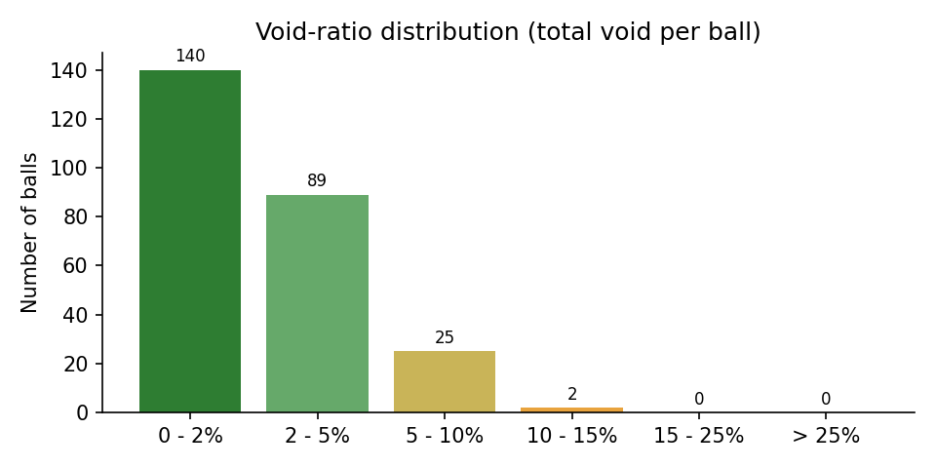

IPC criteria evaluation
Criterion | Source | Limit | Measured | Result
Cumulative void area per ball | IPC-A-610 (Class 1, 2, 3) | <= 25% of ball area | worst ball: 10.75% | PASS
Process indicator band (total void 10-25%) | IPC-7095 process guidance | monitor, not a defect | 2 ball(s) in band | INFO
Largest single void per ball | IPC-7095 (dominant-void guidance) | review above 12.2% area (~35% diameter) | worst single void: 29.0% of ball diameter | PASS
Void location at pad interface | IPC-7095 (30% dia at land) | requires oblique/3D view | not measurable in one top-down 2D X-ray | NOT EVALUATED
Complete ball grid detected | detection integrity gate | all expected pads found | 256 / 256 | PASS

Worst 10 balls by total void
Ball ID | X (px) | Y (px) | Total void (%) | Largest void (%) | IPC assessment
196 | 615 | 1521 | 10.75 | 8.42 | PROCESS INDICATOR
206 | 1908 | 1521 | 10.04 | 5.02 | PROCESS INDICATOR
207 | 2009 | 1521 | 9.27 | 4.00 | ACCEPTABLE
252 | 813 | 1822 | 9.02 | 6.97 | ACCEPTABLE
226 | 714 | 1720 | 8.45 | 4.00 | ACCEPTABLE
4 | 2005 | 313 | 8.13 | 3.78 | ACCEPTABLE
219 | 1408 | 1621 | 7.36 | 3.47 | ACCEPTABLE
187 | 713 | 1422 | 6.93 | 2.86 | ACCEPTABLE
243 | 911 | 1820 | 6.79 | 3.32 | ACCEPTABLE
213 | 911 | 1620 | 6.68 | 4.28 | ACCEPTABLE

Annotated X-ray (detected voids)
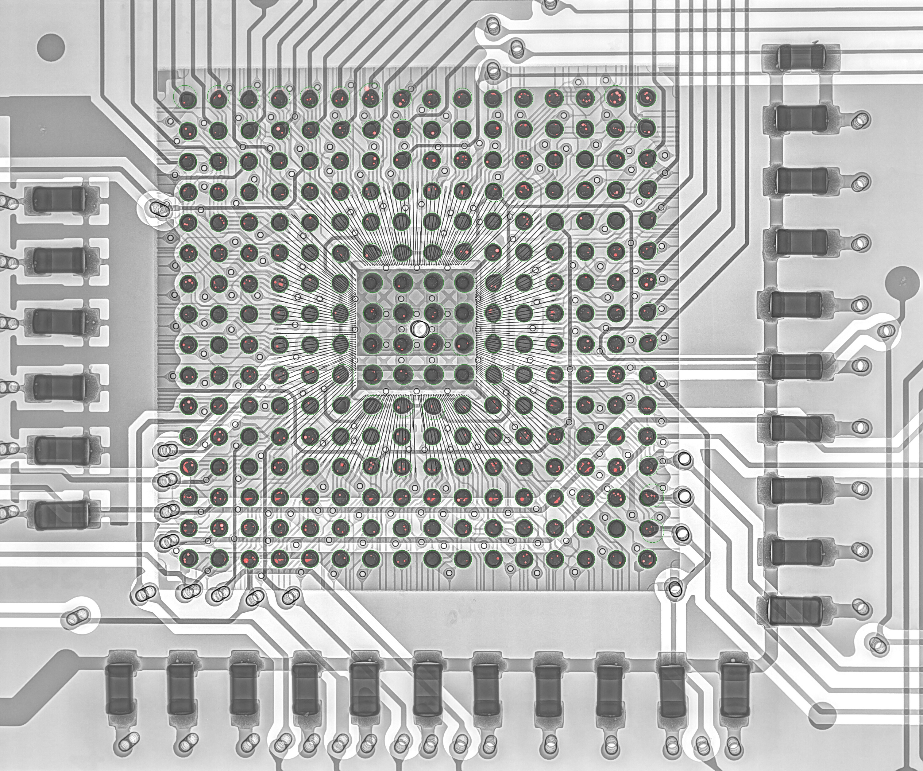

Algorithm analysis - honest assessment

Detection integrity
- Balls detected: 256 of 256 expected grid slots
- Pads placed from grid estimation (no direct evidence): 0
- Mean detection confidence (evidence-backed pads): 1.00
- Ball quality split: 254 PASS / 2 REVIEW / 0 FAIL

Measurement pipeline (what actually produced these numbers)
- 1. CLAHE contrast enhancement + median denoising of the raw X-ray.
- 2. Solder-ball detection: Hough circles + dark-blob evidence, regularized onto the 16x16 BGA grid (affine + homography fit for oblique views, per-ball local snap with non-degradation gates).
- 3. Per-ball void segmentation: median-background subtraction (kernel > ball radius), bond-wire suppression by grayscale closing, residual threshold, then shape filtering.
- 4. Detected void blobs are rendered as fitted circles when they fill >= 45% of the fitted disc (physical voids are spherical gas bubbles); ragged non-circular structures keep their raw contour.
- 5. Component-level sanity filters remove rim arcs, trace stripes, bare-board bleed-through and empty-pad artifacts before metrics.

Classification thresholds applied
- Defect (FAIL): total void >= 25.0% of ball area (IPC-A-610).
- Process indicator (REVIEW): total void >= 10.0% (IPC-7095 guidance).
- Dominant single void (REVIEW): largest void >= 12.25% of ball area (~35% of ball diameter).

Measurement uncertainty - read before trusting decimals
- Projected-area measurement: one top-down 2D X-ray cannot separate package-interface, mid-ball and pad-interface voids; the 25% IPC-A-610 criterion is applied on the projection, exactly as the standard defines it for X-ray inspection.
- Analysis is restricted to the inner 82% of each ball radius; a void hiding exactly on the ball rim can be underestimated.
- Voids smaller than ~10 px^2 (about 0.15% of a ball) are below the detection floor and are intentionally ignored as noise.
- Fitted-circle rendering slightly increases void area versus the raw threshold blob (it includes the faded bubble edge); this is closer to the physical bubble size but adds ~0.3-0.6 percentage points to board averages compared to raw-contour reporting.
- JPEG compression artifacts and CLAHE amplification set a noise floor around 1-2% void ratio; differences below that level are not meaningful.
- On oblique views, perspective foreshortening distorts both ball and void areas; the ratio is partially self-correcting but not perfectly.

Known limitations of this analysis
- Components mounted on the opposite board side project dark shadows between and over balls; the detector anchors circles on grid geometry to resist this, but heavily shadowed balls have reduced void sensitivity.
- Grid slots occupied by vias (no ball populated) are still reported as balls when the slot must be filled; they show ~0% void and near-board brightness.
- Bond-wire suppression (morphological closing) can mask very thin elongated voids lying exactly under a wire.
- The tool measures voiding only; it does not assess head-in-pillow, non-wet opens, bridging or solder-ball shape defects.

Balls to verify manually first (worst 10 by total void)
- Ball #196 at (615, 1521): total 10.75%, largest single 8.42% -> PROCESS INDICATOR
- Ball #206 at (1908, 1521): total 10.04%, largest single 5.02% -> PROCESS INDICATOR
- Ball #207 at (2009, 1521): total 9.27%, largest single 4.00% -> ACCEPTABLE
- Ball #252 at (813, 1822): total 9.02%, largest single 6.97% -> ACCEPTABLE
- Ball #226 at (714, 1720): total 8.45%, largest single 4.00% -> ACCEPTABLE
- Ball # 4 at (2005, 313): total 8.13%, largest single 3.78% -> ACCEPTABLE
- Ball #219 at (1408, 1621): total 7.36%, largest single 3.47% -> ACCEPTABLE
- Ball #187 at (713, 1422): total 6.93%, largest single 2.86% -> ACCEPTABLE
- Ball #243 at (911, 1820): total 6.79%, largest single 3.32% -> ACCEPTABLE
- Ball #213 at (911, 1620): total 6.68%, largest single 4.28% -> ACCEPTABLE

Grid-estimated pads (verify visually)
- None - every pad was detected from direct image evidence.
Generated automatically by BGA X-ray Void Inspection Tool on 2026-07-09 19:57. Verdicts follow IPC-A-610 (25% cumulative projected void area per ball) with IPC-7095 process guidance; they are based on a single top-down 2D X-ray projection and should be confirmed by an operator for boards flagged REVIEW or REJECT.

